Numerical Computing II Homework 6

Samuel Vidovich

We must solve the equation y’ = Ay.

$A=\left[\begin{matrix}-1 & 1 \\ 0 & -2\end{matrix}\right], y_{0}=\left\{\begin{aligned}1 \\ 1\end{aligned}\right.$

Now *A* has eigenvalues $\left\{\begin{aligned}λ_{1}=-1 \\ λ_{2}=-2\end{aligned}\right.$ and eigenvectors $v_{1}=\left({1 \atop 0}\right), v_{2}=\left({-1 \atop 1}\right)$.

Construct the solution product:

$$\left[\begin{matrix}1 & -1 \\ 0 & 1\end{matrix}\right]\left[\begin{matrix}e^{-t} & 0 \\ 0 & e^{-2t}\end{matrix}\right]\left[\begin{matrix}1 & 1 \\ 0 & 1\end{matrix}\right]\left({1 \atop 1}\right)=\left({2e^{-t}-e^{-2t} \atop e^{-2t}}\right)$$

$A=\left[\begin{matrix}-1 & 1 \\ 0 & 2\end{matrix}\right], y_{0}=\left\{\begin{aligned}1 \\ 1\end{aligned}\right.$

Now *A* has eigenvalues $\left\{\begin{aligned}λ_{1}=-1 \\ λ_{2}=2\end{aligned}\right.$ and eigenvectors $v_{1}=\left({1 \atop 0}\right), v_{2}=\left({1 \atop 3}\right)$.

Construct the solution product:

$$\left[\begin{matrix}1 & 1 \\ 0 & 3\end{matrix}\right]\left[\begin{matrix}e^{-t} & 0 \\ 0 & e^{2t}\end{matrix}\right]\left[\begin{matrix}1 & -\frac{1}{3} \\ 0 & \frac{1}{3}\end{matrix}\right]\left({1 \atop 1}\right)=\left({\frac{2}{3}e^{-t}-{\frac{1}{3}e}^{2t} \atop e^{2t}}\right)$$

Some Visuals:

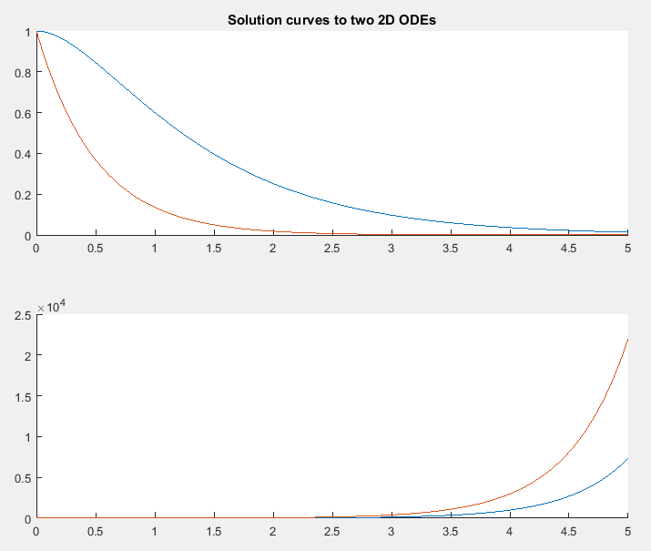

The code used to generate these:

t = linspace(0,5);

n = length(t);

ylist1 = zeros(2, n);

for i = 1:1:n

ylist1(1,i) = 2\*exp(-t(i)) - exp(-2\*t(i));

ylist1(2,i) = exp(-2\*t(i));

end

ylist2 = zeros(2, n);

for i = 1:1:n

ylist2(1,i) = (2/3)\*exp(-t(i)) + (1/3)\*exp(2\*t(i));

ylist2(2,i) = exp(2\*t(i));

end

figure(1)

subplot(2,1,1)

hold on

plot(t, ylist1(1,:))

plot(t, ylist1(2,:))

hold off

title('Solution curves to two 2D ODEs')

subplot(2,1,2)

hold on

plot(t, ylist2(1,:))

plot(t, ylist2(2,:))

hold off